**PLANT DISEASE IDENTIFICATION AND VISUALIZATION: CASE STUDY WITH TOMATO, GRAPES AND CORN**.

*Report submitted to SASTRA Deemed to be University*

*As per the requirement for the course*

**CSE300: MINI PROJECT**

*Submitted by*

**Lakshmi Prabha N**

**(125003158 , B. Tech Computer Science and Engineering)**

**Nidharshana N P**

**(125003208 , B. Tech Computer Science and Engineering)**

**Sarubala R**

**(125003295 , B. Tech Computer Science and Engineering)**

**April 2024**



**SCHOOL OF COMPUTING**

**THANJAVUR, TAMIL NADU, INDIA – 613 401**



**SCHOOL OF COMPUTING**

**THANJAVUR – 613 401**

**Bonafide Certificate**

This is to certify that the report titled **“Plant Disease Identification and Visualization: Case study with Tomato, Grapes and Maize.”** submitted as a requirement for the course, **CSE300: MINI PROJECT** for B.Tech. is a bonafide record of the work done by **Ms. Lakshmi Prabha N (125003158, B. Tech Computer Science and Engineering**), **Ms. Nidharshana N P (125003208, B. Tech Computer Science and Engineering)**  and **Ms. Sarubala R (125003295, B. Tech Computer Science and Engineering)** during the academic year 2023-24, in the School of Computing, under my supervision.

**Signature of Project Supervisor :**

**Name with Affiliation :**

**Date :**

Mini Project *Viva voice* held on ________________

**Examiner 1 Examiner 2**

**ACKNOWLEDGEMENTS**

We would like to thank our Honorable Vice-Chancellor **Dr. S. Vaidhyasubramaniam** and **Dr. S. Swaminathan**, Dean, Planning & Development, for the encouragement and strategic support at every step of our college life.

We extend our sincere thanks to **Dr. R. Chandramouli**, Registrar, SASTRA Deemed to be University for providing the opportunity to pursue this project.We extend our heartfelt thanks to **Dr. V. S. Shankar Sriram**, Dean, School of Computing, SASTRA Deemed to be University.

Our guide **Dr. N.Sasikala Devi** , Associate Professor, School of Computing was the driving force behind this whole idea from the start. Her deep insight in the field and invaluable suggestions helped us in making progress throughout our project work. We also thank the project review panel members for their valuable comments and insights which made this project better.

We would like to extend our gratitude to all the teaching and non-teaching faculties of the School of Computing who have either directly or indirectly helped us in the completion of the project.

We gratefully acknowledge all the contributions and encouragement from my family and friends resulting in the successful completion of this project. We thank you all for providing us an opportunity to showcase our skills through this project.

**List of Figures**

|  |  |  |
| --- | --- | --- |
| **Fig No.** | **Title** | **Page No.** |
| 1.1 | Proposed Framework for Tomato Plant Leaves | 6 |
| 1.2 | Proposed Framework for Grape Plant Leaves | 6 |
| 1.3 | Proposed Framework for Maize Plant Leaves | 7 |
| 1.4 | Architecture of EfficientNet | 8 |
| 4.1 | Feature Extraction from Tomato Plant Dataset | 23 |
| 4.2 | Classification using SVM | 23 |
| 4.3 | Deep Learning Metrics | 24 |
| 4.4 | Confusion Matrix for Quadratic SVM | 24 |
| 4.5 | ROC for Quadratic SVM | 25 |
| 4.6 | Meta-Visualization using Grad-CAM for Tomato Plant Disease | 25 |
| 4.7 | Feature Extraction from Grape Plant Dataset | 27 |
| 4.8 | Confusion Matrix | 28 |
| 4.9 | ROC Curve | 28 |
| 4.10 | Meta-Visualization using Grad-CAM for Grapes leaves | 29 |
| 4.11 | Confusion Matrix for Wide Neural Network | 29 |
| 4.12 | ROC Curve for Wide Neural Network | 30 |
| 4.13 | Meta-Visualization using Grad-CAM for Maize leaves | 31 |

**List of Tables**

|  |  |  |
| --- | --- | --- |
| **Table No.** | **Title** | **Page No.** |
| 1.1 | Deep Learning Metrics for Tomato Disease Detection | 12 |
| 1.2 | Deep Learning Metrics for Grape Disease Detection | 13 |

**Abbreviations**

|  |  |
| --- | --- |
| CNN | Convolutional Neural Network |
| Grad-CAM | Gradient-weighted Class Activation Mapping |
| MFFN | Multilevel Feature Fusion Network |
| ReLU | Rectified Linear Unit |
| SVM | Support Vector Machine |
| ToMV | Tomato mosaic virus |
| TYLCV | Tomato Yellow Leaf Curl Virus |

**Notations**

**English Symbols (in alphabetical order)**

* $b$ is the bias term.
* *C* is the regularization parameter.
* $F^{k}$ is the represent the k-th feature map
* $L^{c}$ is the activation map
* $w$ is the weight vector.
* $Y^{c}$ represents the output class score.
* $y_{i}$ ​ is the class label of sample $x_{i}$ ​.
* $z$ is the output of the hidden layer.

**Greek Symbols (in alphabetical order)**

* $σ$ represents activation function.
* $ξ_{i}$ represents slack variables, representing the degree of misclassification for each sample.

**ABSTRACT**

Crops play a vital role in India, acting as a foundation of the agricultural industry and the source of livelihood for millions. However, the production of crops often encounters significant obstacles due to diseases that impact crucial crops such as tomatoes, corn, and grapes. These diseases can result in reduced yields, financial difficulties for farmers, and food insecurity. Detecting these diseases promptly is essential to minimize their effects and guarantee a healthy crop output. To tackle these issues, we suggest creating a sophisticated deep convolutional neural network (CNN) in conjunction with tailored machine learning methods. This strategy is designed to identify features and categorize weeds, pests, and diseases that affect the leaves of tomato, corn, and grape plants. By utilizing a dataset containing images of these leaves, our aim is to train and validate this deep learning model to achieve the highest possible validation accuracy. Our objective is to outperform current techniques associated with plant datasets, thereby providing a more efficient solution for addressing challenges in crop production. By facilitating early and precise disease identification, we can equip farmers with timely interventions, ultimately improving crop yields and ensuring food security for India's expanding population.

**KEY WORDS**: Tomato Plants; Grape Plants; Corn Plants; CNN; Light weight

**Table of Contents**

**Title Page No.**

Bonafide Certificate ii

Acknowledgements iii

List of Figures iv

List of Tables v

Abbreviations vi

Notations vii

Abstract viii

1. Summary of the base paper 1

2. Merits and Demerits of the base paper 15

3. Source Code 18

4. Output Snapshots 21

5. Conclusion and Future Plans 32

6. References 33

7. Appendix -Base Paper 36

**CHAPTER 1**

**SUMMARY OF THE BASE PAPER**

|  |  |  |
| --- | --- | --- |
| Title | : | Tomato plant disease classification using Multilevel Feature Fusion with adaptive channel spatial and pixel attention mechanism |
| Publisher | **:** | ScienceDirect |
| Year | **:** | 2023 |
| Journal name | **:** | Expert Systems With Applications |
| DOI | **:** | 10.1016/j.eswa.2023.120381 |
| Base paper URL | **:** | https://www.sciencedirect.com/science/article/abs/pii/S0957417423008837 |

The main contributions of the base paper are:

* Introduction of Multilevel Feature Fusion Network (MFFN) for tomato plant disease classification.
* Integration of ResNet50 architecture and Adaptive Attention Mechanism in the proposed model.
* Achievement of high accuracy rates in training, validation, and external testing phases.
* Development of a pesticide prescription module based on the identified leaf disease type

**1.1 INTRODUCTION:**

Plant diseases have the potential to cause severe damage to agricultural production, posing significant risks to both food security and economic stability. The leaves of plants often serve as the first indicators of trouble, as they bear the burden of displaying disease symptoms. These symptoms can vary from discoloration and lesions to wilting and abnormal growth patterns. However, despite their prominence, farmers may misdiagnose diseases due to the similarities in symptoms or their lack of expertise, which can lead to incorrect treatment measures. Such misdiagnoses can be extremely dangerous. Applying incorrect treatments not only fails to address the underlying issue but can also worsen it, resulting in yield losses, crop damage, and increased financial burdens on farmers. Furthermore, the spread of undetected diseases can escalate into epidemics, impacting entire regions and compromising the sustainability of agriculture. Therefore, there is an urgent need for robust methods of identifying plant diseases. By equipping farmers with accurate diagnostic tools and knowledge, we can effectively mitigate the adverse effects of plant diseases and safeguard global food production.

Early detection of diseases plays a vital role in successful disease control. Hence, it is essential to comprehend the causes and outcomes of these illnesses.

**1.1.1. Diseases Commonly Found in Tomato Plants:**

**1.1.1.1. Bacterial Spot**:

Tomato plants impacted by bacterial spot display dark lesions on their leaves and fruit, caused by Xanthomonas campestris pv. vesicatoria bacteria thriving in warm, humid settings. This condition leads to leaf defoliation, deterioration in fruit quality, and yield reductions, significantly affecting tomato cultivation.

**1.1.1.2. Early Blight:**

Early blight, frequently seen in tomato plants, appears as dark lesions on lower leaves due to the fungus Alternaria solani in warm, moist conditions. It causes leaf discoloration, premature loss, and decreased fruit yield, posing significant challenges to cultivation efforts.

**1.1.1.3. Late Blight:**

Late blight, originating from Phytophthora infestans, results in water-soaked lesions on tomato leaves that spread quickly in humid, cool conditions. This disease harms foliage, diminishes fruit yield and quality, and presents obstacles to cultivation endeavors.

**1.1.1.4. Leaf Mold**:

Leaf mold, caused by the fungus Fulvia fulva, shows as yellowish or brownish patches on the underside of tomato leaves. Thriving in warm and humid conditions, it spreads rapidly, impacting fruit production significantly. It is crucial to implement effective control measures to reduce substantial losses in tomato crops.

**1.1.1.5. Septoria Leaf Spot**:

Septoria leaf spot, induced by the fungus Septoria lycopersici, causes small dark spots on tomato leaves, spreading quickly in warm, humid conditions. It leads to defoliation and reduced fruit yield, requiring the adoption of efficient management strategies.

**1.1.1.6. Two-Spotted Spider Mite:**

The two-spotted spider mite, a common pest in agriculture, causes damage to leaves and leads to their dropping by feeding on the undersides of leaves. These pests reproduce quickly and develop resistance to pesticides, which poses challenges for growers. To effectively manage these pests and protect crop yields, it is crucial to employ effective control measures such as biological agents and cultural practices.

**1.1.1.7. Target Spot:**

Target spot, a fungal disease, appears as circular lesions with concentric rings on tomato leaves. This disease thrives in warm and humid conditions, spreading rapidly and causing leaf yellowing and defoliation. Proper management of target spot and minimizing its impact on tomato crops requires the use of fungicidal treatments and maintaining good sanitation practices.

**1.1.1.8. Tomato Yellow Leaf Curl Virus (TYLCV):**

The Tomato Yellow Leaf Curl Virus (TYLCV) is a destructive disease that is transmitted by whiteflies, resulting in leaf yellowing, curling, and reduced fruit yield in tomato plants. This virus poses a global threat to cultivation, making integrated pest management and the use of resistant varieties essential for effective control.

**1.1.1.9. Tomato Mosaic Virus (ToMV):**

Tomato mosaic virus (ToMV) is a common viral disease in tomatoes, characterized by mosaic patterns on leaves, stunted growth, and decreased yield. To minimize the impact of this disease on crops, it is important to implement proper disease management practices, such as using virus-free seedlings.

**1.1.1.10. Healthy:**

Tomato plants in a state of good health display robust green leaves, strong stems, and vigorous growth. They also exhibit abundant flowering and fruit production. This overall well-being of the plants indicates their resilience against pests and diseases.

**1.1.2.Diseases commonly found in grape plants:**

**1.1.2.1. Black Measles:**

Black measles is caused by Phomopsis viticola, resulting in small dark circular lesions on grapevine parts, impacting fruit quality and vine health in warm, humid conditions.

**1.1.2.2. Black Rot:**

Caused by Guignardia bidwellii, black rot leads to large black lesions on leaves, stems, and fruit, causing significant yield losses in warm, moist climates.

**1.1.2.3. Leaf Blight:**

This disease, caused by Phomopsis viticola, causes dark lesions on grapevine leaves, leading to defoliation and reduced photosynthesis, particularly in humid environments.

**1.1.2.4. Healthy:**

A healthy grapevine has vibrant green leaves, sturdy stems, and abundant clusters of grapes, showing resilience to diseases and pests with proper management practices.

**1.1.3.Diseases commonly found in maize plants:**

**1.1.3.1.Cercospora Leaf Gray Spot Leaf:**

Cercospora Leaf Gray Spot, induced by the fungus Cercospora zeae-maydis, is a common leaf disease that impacts maize crops worldwide. It appears as circular lesions with gray centers and dark edges on the leaves, resulting in decreased photosynthetic capability and lower crop yields. To combat this issue, farmers can implement practices such as crop rotation, the use of fungicides, and the cultivation of maize varieties that are resistant to the disease. It is crucial to conduct regular surveillance and intervene promptly to effectively manage Cercospora Leaf Gray Spot in maize fields.

**1.1.3.2.Common Rust:**

Common rust of maize plant, caused by the fungus Puccinia sorghi, is characterized by reddish-brown lesions on leaves. These lesions contain powdery masses of rust-colored spores. The disease spreads rapidly in humid conditions, impacting photosynthesis and reducing yield. Management involves planting resistant varieties and applying fungicides as needed. Timely intervention is crucial to mitigate its effects on maize production.

**1.1.3.3.Northern Leaf Blight:**

Exserohilum turcicum is the fungus that causes Northern Leaf Blight, which is a global problem that affects maize plants. The disease causes large, cigar-shaped lesions on the leaves of the plant, usually beginning from the lower leaves and moving upward. Severe infections can cause significant yield losses by reducing photosynthesis and weakening the plant; common management strategies include crop rotation and resistant varieties, along with the application of fungicide when needed. Early detection and intervention are crucial to minimizing the effects of Northern Leaf Blight on maize crops.

**1.1.3.4.Healthy:**

A maize plant's healthy leaf has a uniform shape, a vivid green hue, and no lesions or discoloration. Its upright and turgid appearance suggests sufficient water absorption and structural integrity. There are no anomalous growths or abnormalities on the flat surface of the leaf. Properly functioning maize leaves are essential for photosynthesis, which promotes the growth and development of plants. It is imperative to conduct routine assessments of leaf health in order to sustain ideal maize crop productivity.

**1.2 PROPOSED MODEL FOR TOMATO PLANT DISEASE DETECTION:**

The proposed deep learning model encompasses fine-tuned feature extraction, machine learning-based classification, as well as phases for training, validation, and meta-visualization. Plant leaf disease images were obtained from the PlantVillage dataset and divided into a 70% training set and a 30% validation set.

|  |
| --- |
|  |

Fig 1.1. Proposed Framework for Tomato Plant Leaves

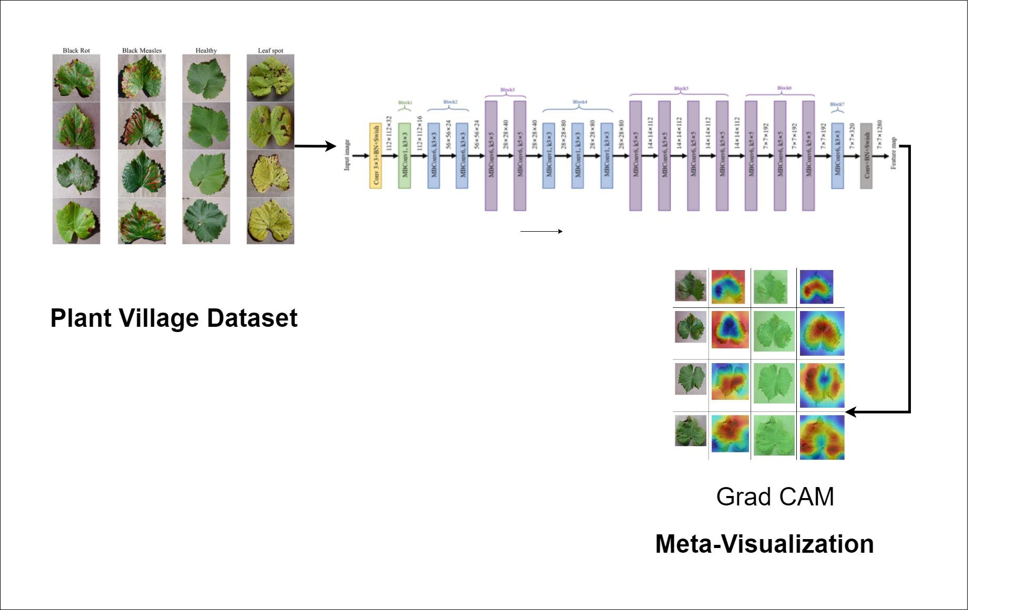

Fig 1.2. Proposed Framework for Grape Plant Leaves

|  |
| --- |
|  |

Fig 1.3. Proposed Framework for Maize Plant Leaves

**1.2.1. FEATURE EXTRACTION FOR TOMATO, CORN AND GRAPE PLANT LEAVES:**

EfficientNet-B0, known for its exceptional feature extraction capabilities, serves as a potent tool for disease detection in tomato, corn, and grape leaves. By leveraging its hierarchical representations learned through extensive training on diverse datasets, EfficientNet-B0 can effectively capture subtle visual cues indicative of disease symptoms such as discoloration, lesions, and abnormal growth patterns. Through convolutional layers optimized for extracting features at multiple scales, it can discern nuanced variations in leaf texture, shape, and color associated with specific diseases plaguing these crops. In the realm of agricultural disease detection, EfficientNet-B0 offers a promising avenue for early diagnosis and mitigation of plant ailments, enabling swift identification and response to outbreaks, minimizing crop losses, and ensuring food security. By integrating EfficientNet-B0 into disease detection systems tailored for tomato, corn, and grape cultivation, stakeholders can enhance monitoring efforts, implement targeted interventions, and ultimately safeguard agricultural productivity and sustainability.

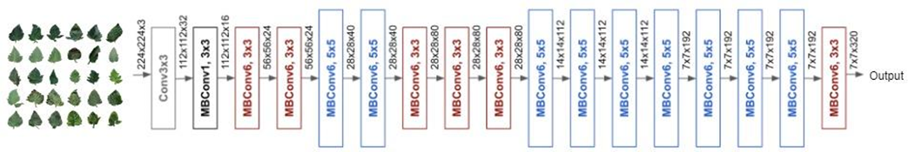

Fig. 1.4 Architecture of EfficientNet

**1.2.2. MACHINE LEARNING BASED CLASSIFICATION:**

**1.2.2.1. TOMATO PLANT LEAVES:**

SVM is a strong choice for classifying tomato leaves into nine disease categories and one healthy class. Its efficiency in handling high-dimensional data makes it particularly suitable for this task. SVM works by finding the best hyperplane to separate data points of different classes while maximizing the margin between them. This is beneficial for complex and overlapping feature spaces common in plant disease classification. SVM's flexibility allows it to handle various types of features, such as color histograms, texture features, and shape descriptors extracted from leaf images. It can effectively discriminate between different disease classes and healthy leaves using these diverse feature sets. Moreover, SVM is robust to noise and can handle imbalanced datasets, common challenges in this domain. Overall, SVM offers a reliable and scalable solution for automated tomato disease diagnosis, aiding in early detection and management of plant diseases for improved crop yield and food security.

**1.2.2.1.1. Mathematical Representation of Quadratic SVM:**

The objective function of the quadratic SVM is a trade-off between maximizing the margin and minimizing the classification error. It's defined as follows:

Minimize $\frac{1}{2}w^{T}w+C\sum_{i=1}^{N}{}ξ_{i}^{2}$ (1.1)

where:

* $w$ is the weight vector.
* *C* is the regularization parameter.
* $ξ_{i}$ are slack variables, representing the degree of misclassification for each sample

The term $\frac{1}{2}w^{T}w$ encourages maximizing the margin between the support vectors, while the term $C\sum_{i=1}^{N}{}ξ_{i}^{2}$ penalizes misclassifications.

**Constraints:** The constraints ensure that each sample is correctly classified within the margin:

$y_{i}\left(w^{T}x_{i}+b\right)≥1-ξ_{i}$ for $ⅈ=1,2,…,N$ (1.2)

where:

* $y_{i}$ ​ is the class label of sample $x_{i}$ ​.
* $b$ is the bias term.

These constraints enforce that the decision function $w^{T}x_{i}+b$ is greater than or equal to 1 for correctly classified samples, and the slack variables allow for some tolerance for misclassifications.

**Quadratic Programming:** The optimization problem in the quadratic SVM formulation is a quadratic programming problem, which can be solved using various optimization techniques. The goal is to find the optimal values of $w$ and $b$ that minimize the objective function while satisfying the constraints.

**Decision Function:** Once the optimization problem is solved, the decision function for predicting the class label of a new sample $x$ is given by:

$y\left(x\right)=sign\left(w^{T}x+b\right)$ (1.3)

where the sign function assigns the class label based on the sign of $w^{T}x+b$

This detailed formulation allows for a flexible decision boundary, incorporating both linear and non-linear aspects through the kernel trick. By tuning the regularization parameter $C$ and choosing an appropriate kernel function, the quadratic SVM can handle complex classification tasks effectively.

**1.2.2.2. MAIZE PLANT LEAVES:**

Wide neural networks offer a robust solution for the precise and early detection of maize plant diseases, which is essential for maintaining crop health and ensuring food security. These networks, with their expansive architecture and numerous neurons in hidden layers, are adept at capturing intricate patterns that are indicative of various maize diseases, including common threats like maize streak virus, gray leaf spot, and northern corn leaf blight. By analyzing diverse features extracted from images of affected plants, such as color variations, texture details, and shape characteristics, wide neural networks enable accurate disease classification. Their adaptability to high-dimensional data and ability to discern complex relationships make them well-suited for navigating the complex landscape of plant disease classification. Through the use of wide neural networks, agricultural practitioners can take proactive measures to reduce crop losses, ultimately contributing to sustainable agricultural practices and global food security.

**1.2.2.2.1 Mathematical Representation of Wide Neural Network:**

The mathematical representation of a wide neural network with one hidden layer:

**Input Layer**:

* + : Input vector with dimension $n$, representing the features of the input data.

**Hidden Layer**:

* + : Weight matrix connecting the input layer to the hidden layer, with dimensions $m×n$, where $m$ is the number of neurons in the hidden layer.
  + $b^{\left(1\right)}$: Bias vector for the hidden layer, with dimension $m$.
  + $σ$: Activation function applied element-wise to the weighted sum of inputs to introduce non-linearity. Common activation functions include ReLU, sigmoid, tanh, etc.
  + The output of the hidden layer ($z$) is calculated as follows:

$z=σ\left(w^{\left(1\right)}x+b^{\left(1\right)}\right)$ (1.4)

Here, $w^{\left(1\right)}x$ represents the linear transformation of the input data by the weight matrix, and $+b^{\left(1\right)}$ adds the bias vector.

**Output Layer**:

* + : Weight matrix connecting the hidden layer to the output layer, with dimensions $p×m$, where $p$ is the number of neurons in the output layer.
  + $b^{\left(2\right)}$: Bias vector for the output layer, with dimension $p$.
  + The final output ($\hat{Y}$) of the neural network is calculated as follows:

$\hat{Y}=w^{\left(2\right)}z+b^{\left(2\right)}$ (1.5)

Here, $w^{\left(2\right)}z$ represents the linear transformation of the hidden layer output, and $+b^{\left(2\right)}$ adds the bias vector for the output layer.

**Vectorized Form**: In vectorized form, the computation can be expressed as:

$\hat{Y}=w^{\left(2\right)}σ\left(w^{\left(1\right)}X+b^{\left(1\right)}\right)+b^{\left(2\right)}$ (1.6)

This representation captures the flow of information through the neural network, from the input layer through the hidden layer to the output layer. The parameters of the network, namely the weights ( $w^{\left(1\right)}$ and $w^{\left(2\right)}$) and biases ( $b^{\left(1\right)}$ and $b^{\left(2\right)}$), are learned through the process of training using techniques like backpropagation and gradient descent.

**1.2.3. DEEP LEARNING METRICS:**

Our deep learning assessment incorporates metrics such as precision, sensitivity, specificity, accuracy, and F1 score. In order to determine the comprehensive metrics (precision, sensitivity, specificity, accuracy, and F1 score) across the complete dataset, it is possible to combine the results from all categories.

1.2.3.1. Precision:

$$Precision=\frac{True Positives}{True Positives+False Positives}$$

1.2.3.2. Sensitivity:

$$Sensitivity=\frac{True Positives}{True Positives+False Negatives}$$

1.2.3.3. Specificity:

$$Specificity=\frac{True Negatives}{True Negatives+False Positives}$$

1.2.3.4. Accuracy:

$$Accuracy=\frac{True Positives+True Negatives}{Total Population}$$

1.2.3.4.5.F1 Score (harmonic mean of precision and sensitivity):

$$F1=2*\frac{Precision*Sensitivity}{Precision+Sensitivity}$$

**1.2.3.1. TOMATO PLANT DISEASE DETECTION:**

Table 1.1 Deep Learning Metrics for Tomato Disease Detection

|  |  |  |  |  |  |  |  |  |  |  |  |  |
| --- | --- | --- | --- | --- | --- | --- | --- | --- | --- | --- | --- | --- |
| Name | Bacterial spot | Early blight | Late blight | Leaf Mold | Septoria leaf spot | Two spotted spider mite | Target Spot | Tomato Yellow Leaf Curl Virus | Tomato Mosaic Virus | healthy | macroAVG | microAVG |
| true_positive | 637 | 714 | 690 | 706 | 651 | 652 | 681 | 731 | 671 | 720 | 685.3 | 685.3 |
| false_positive | 8 | 2 | 4 | 0 | 0 | 3 | 6 | 0 | 0 | 2 | 2.5 | 2.5 |
| false_negative | 1 | 6 | 4 | 0 | 3 | 1 | 4 | 4 | 0 | 2 | 2.5 | 2.5 |
| true_negative | 6232 | 6156 | 6180 | 6172 | 6224 | 6222 | 6187 | 6143 | 6207 | 6154 | 6187.7 | 6187.7 |
| precision | 0.987596899 | 0.997206704 | 0.994236311 | 1 | 1 | 0.995419847 | 0.991266376 | 1 | 1 | 0.997229917 | 0.996295605 | 0.996365222 |
| sensitivity | 0.998432602 | 0.991666667 | 0.994236311 | 1 | 0.995412844 | 0.998468606 | 0.994160584 | 0.994557823 | 1 | 0.997229917 | 0.996416535 | 0.996365222 |
| specificity | 0.998717949 | 0.999675219 | 0.999353169 | 1 | 1 | 0.999518072 | 0.999031164 | 1 | 1 | 0.999675114 | 0.999597069 | 0.999596136 |
| accuracy | 0.996365222 | 0.996365222 | 0.996365222 | 0.996365222 | 0.996365222 | 0.996365222 | 0.996365222 | 0.996365222 | 0.996365222 | 0.996365222 | 0.996365222 | 0.996365222 |
| F-measure | 0.992985191 | 0.994428969 | 0.994236311 | 1 | 0.997701149 | 0.996941896 | 0.99271137 | 0.997271487 | 1 | 0.997229917 | 0.996350629 | 0.996365222 |

The precision, sensitivity, specificity, accuracy, and F1 score for the entire tomato dataset are 0.997894296, 0.997317536,0.999606471, 0.996365222, and 0.996580628 respectively.

**1.2.3.2.GRAPE PLANT DISEASE DETECTION:**

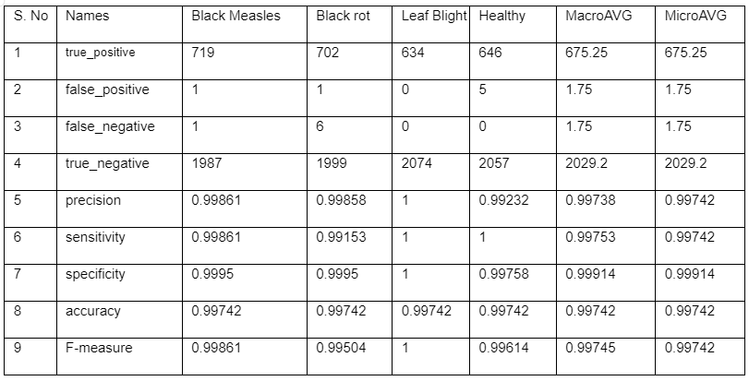

Table 1.1 Deep Learning Metrics for Tomato Disease Detection

The precision, sensitivity, specificity, accuracy, and F1 score for the entire grape dataset are 0.99738, 0.99753, 0.99914, 0.99742, 0.99745 respectively.

**1.4. META-VISUALIZATION FOR TOMATO, CORN AND GRAPE PLANT LEAVES:**

Meta-visualization techniques, such as Grad-CAM, are utilized in plant disease detection to gain insights into the decision-making process of convolutional neural networks (CNNs). These methods highlight significant regions within plant images, facilitating a deeper understanding of the features guiding the CNN's predictions. This enhances the interpretability of the model's performance, allowing for the identification of disease-related characteristics and the refinement of diagnostic accuracy, thereby advancing strategies for effective plant disease management.

**1.4.1. Grad-CAM:**

Grad-CAM is a visualization technique crucial for plant disease detection, as it highlights the key regions in plant images that influence the convolutional neural network's (CNN) classification decisions. By analyzing gradients in the final convolutional layer, Grad-CAM reveals which parts of the image are most relevant for identifying diseases, enabling researchers to better understand and interpret CNN's predictions. This interpretability enhances the trustworthiness of disease detection models, facilitating more accurate diagnosis and targeted interventions in agricultural settings.

**1.4.1.1. Mathematical Representation**:

The mathematical representation of Grad-CAM involves computing the gradient of the output class score with respect to the feature maps of the last convolutional layer of a CNN. Let $F^{k}$ represent the k-th feature map in the final convolutional layer, and $α_{k}^{c}$ denote the importance of feature map $F^{k}$ for class c. Then, Grad-CAM computes the class activation map $L^{c}$ as follows:

$L^{C}=LU\left(Σ_{k}α_{k}^{C}F^{k}\right)$ (1.7)

where $α_{k}^{C}$ is calculated using the global average pooling of the gradients $\frac{∂Y^{c}}{∂F^{k}}$ ​, where $Y^{c}$ represents the output class score:

$α_{k}^{c}=\frac{1}{z}Σ_{i}Σ_{j}\frac{∂Y^{c}}{∂F_{ⅈj}^{k}}$ (1.8)

Here, $F_{ⅈj}^{k}$ represents the activation of the k-th feature map at position (i, j), and Z is the normalization factor. Finally, ReLU is applied element-wise to ensure only positive contributions are considered. This formulation generates the class activation map highlighting regions in the input image that are most relevant for the CNN's prediction of class c.

**CHAPTER 2**

**MERITS AND DEMERITS OF THE BASE PAPER**

**2.1. LITERATURE SURVEY:**

In recent years, a range of methodologies have been explored in academic research to detect diseases in tomato plants, utilizing machine learning, computer vision, and deep learning methodologies.

* **“Enhanced Deep Learning Architecture for Rapid and Accurate Tomato Plant Disease Diagnosis.” by** Islam et al. (2024) used deep learning in which they evaluated VGG, ResNet, and DenseNet for tomato plant disease identification. Their custom deep neural network achieved over 99% accuracy on datasets with 10 classes, showing promise for efficient agricultural disease detection.
* **“Using a Hybrid Convolutional Neural Network with a Transformer Model for Tomato Leaf Disease Detection” by** Chen et al. (2024) used GAN-based Transformer model for augmenting tomato leaf images, achieving 99.45% accuracy on PlantVillage data and outperforming previous models, showcasing its robustness for crop disease control.
* **“EffiMob-Net: A deep learning-based hybrid model for detection and identification of tomato diseases using leaf images.”** by Ullah et al. (2023) used a hybrid DL-based approach named EffiMob-Net, consisting of EfficientNetB3 and MobileNet pretrained models, trained and tested on a Plant Village dataset containing tomato leaf disease and healthy images.
* **“Detection of tomato leaf diseases for agro-based industries using novel PCA DeepNet”** by Roy et al. (2023) used PCA DeepNet combined with F-RCNN, achieving a classification accuracy of 99.60% and an average precision of 98.55%. The dataset utilized contains a mixture of healthy and diseased tomato leaf images, and the hybrid framework incorporates PCA and GAN techniques for data enhancement.
* **“Automatic blight disease detection in potato (Solanum tuberosum L.) and tomato (Solanum lycopersicum, L. 1753) plants using deep learning.”** byAnim-Ayeko et al.(2023) utilized a ResNet-9 model for the classification of early and late blight diseases in potato and tomato plant leaves. The accuracy achieved was 99.25%, with overall precision of 99.67%, recall of 99.33%, and F1-score of 99.33%. Saliency maps were employed to explain the model's predictions, revealing consideration of leaf shape, diseased areas, and healthy regions.
* **“Effects of different pre trained deep learning algorithms as feature extractor in tomato plant health classification”** by Chong et al. (2023) used pre trained deep learning models (ResNet-50, AlexNet, GoogleNet, VGG16, and VGG19) were used to classify tomato plant health into five categories: healthy, early blight, late blight, bacterial spot, and yellow leaf curl virus. SVM coupled with ResNet-50 achieved the highest accuracy, with training and testing accuracies of 98.26% and 93.33%, respectively.

**MERITS AND DEMERITS**

**Merits:**

To evaluate the merits and demerits of the base paper you mentioned ("Tomato plant disease classification using Multilevel Feature Fusion with adaptive channel spatial and pixel attention mechanism"), we'll consider general aspects that are often relevant in such research:

1. Innovative Approach: The paper presents an innovative approach by combining multilevel feature fusion with adaptive attention mechanisms. This indicates a novel contribution to the field of plant disease classification.

2. Improved Accuracy: The use of advanced techniques like attention mechanisms and feature fusion often leads to improved accuracy in classification tasks. This can be a significant merit if the paper demonstrates superior performance compared to existing methods.

3. Generalizability: If the proposed method shows good performance across different datasets or even across different plant species, it suggests a level of generalizability that enhances the practicality and relevance of the research.

4. Potential for Real-World Application: Effective disease classification in plants has direct implications for agriculture, such as early detection and management of diseases. If the proposed method shows promise for real-world application, it adds substantial value to the research.

**Demerits:**

1. Complexity: Advanced techniques like multilevel feature fusion and adaptive attention mechanisms can make the model architecture and implementation quite complex. This complexity can sometimes make it challenging for others to replicate or extend the research.

2. Computational Cost: Sophisticated models often come with increased computational requirements, including higher memory usage and longer training times. This can limit the scalability of the approach, especially in resource-constrained environments.

3. Data Requirements: Such advanced models often require large and diverse datasets for training. If the base paper does not discuss the data requirements or relies on limited datasets, it may raise questions about the robustness and generalizability of the proposed approach.

4. Evaluation Metrics: The paper should provide a comprehensive evaluation using standard metrics such as accuracy, precision, recall, and F1-score. If the evaluation is limited or lacks comparison with existing state-of-the-art methods, it can be a demerit.

Overall, while the innovative approach and potential for improved accuracy are strengths of the base paper, considerations such as complexity, computational cost, data requirements, and thorough evaluation are important aspects to assess its practicality and impact in the field.

**CHAPTER 3**

**SOURCE CODE**

**3.1. FEATURE EXTRACTION**

**feat.mat**

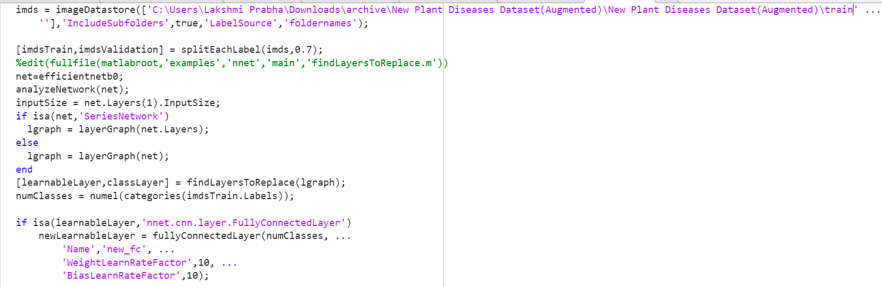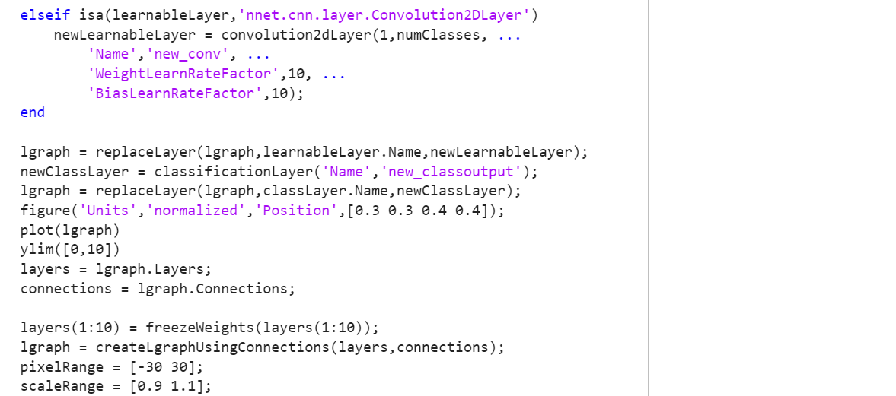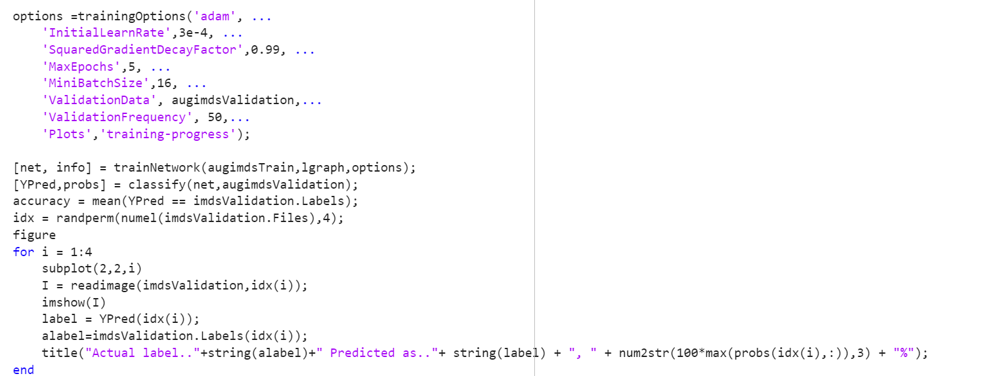

**3.2. CLASSIFICATION**

**classifier.mat**

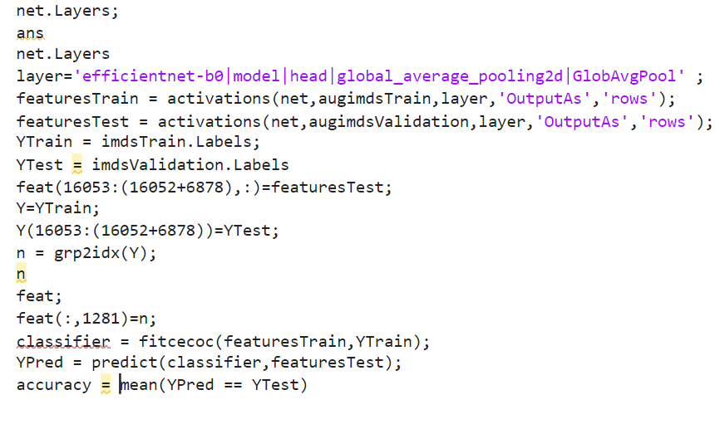

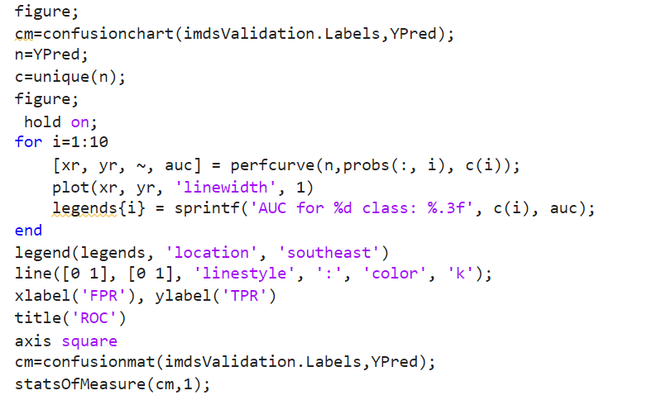

**3.3 META VISUALIZATION**

**gradcam.mat**

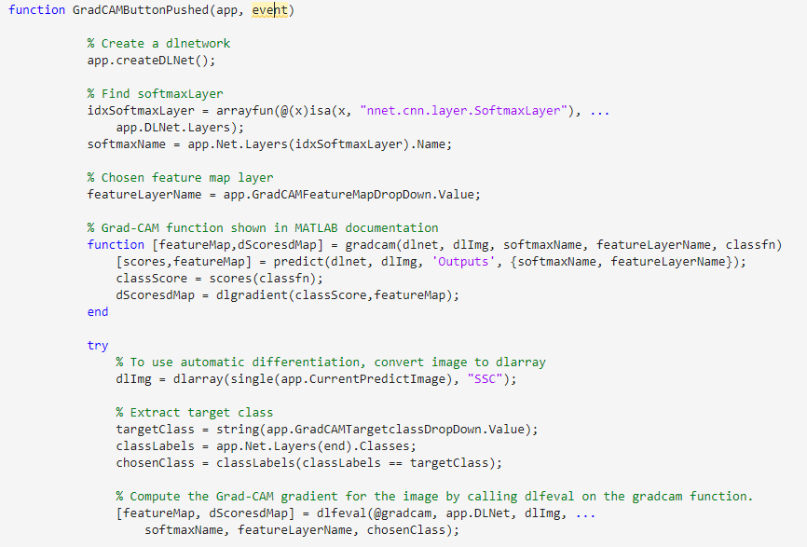

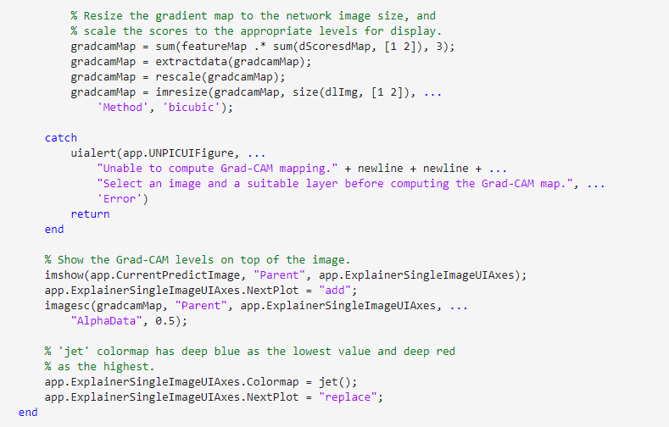

Feature extraction was carried out in a similar manner on datasets that included maize and grape leaves. Following this, classification tasks were executed using a wide neural network for maize and support vector machine (SVM) for tomato. Furthermore, meta-visualization was performed on the tomato, grape, and maize crops.

**CHAPTER 4**

**OUTPUT SNAPSHOTS**

**4.1. Tomato Plant Disease Detection:**

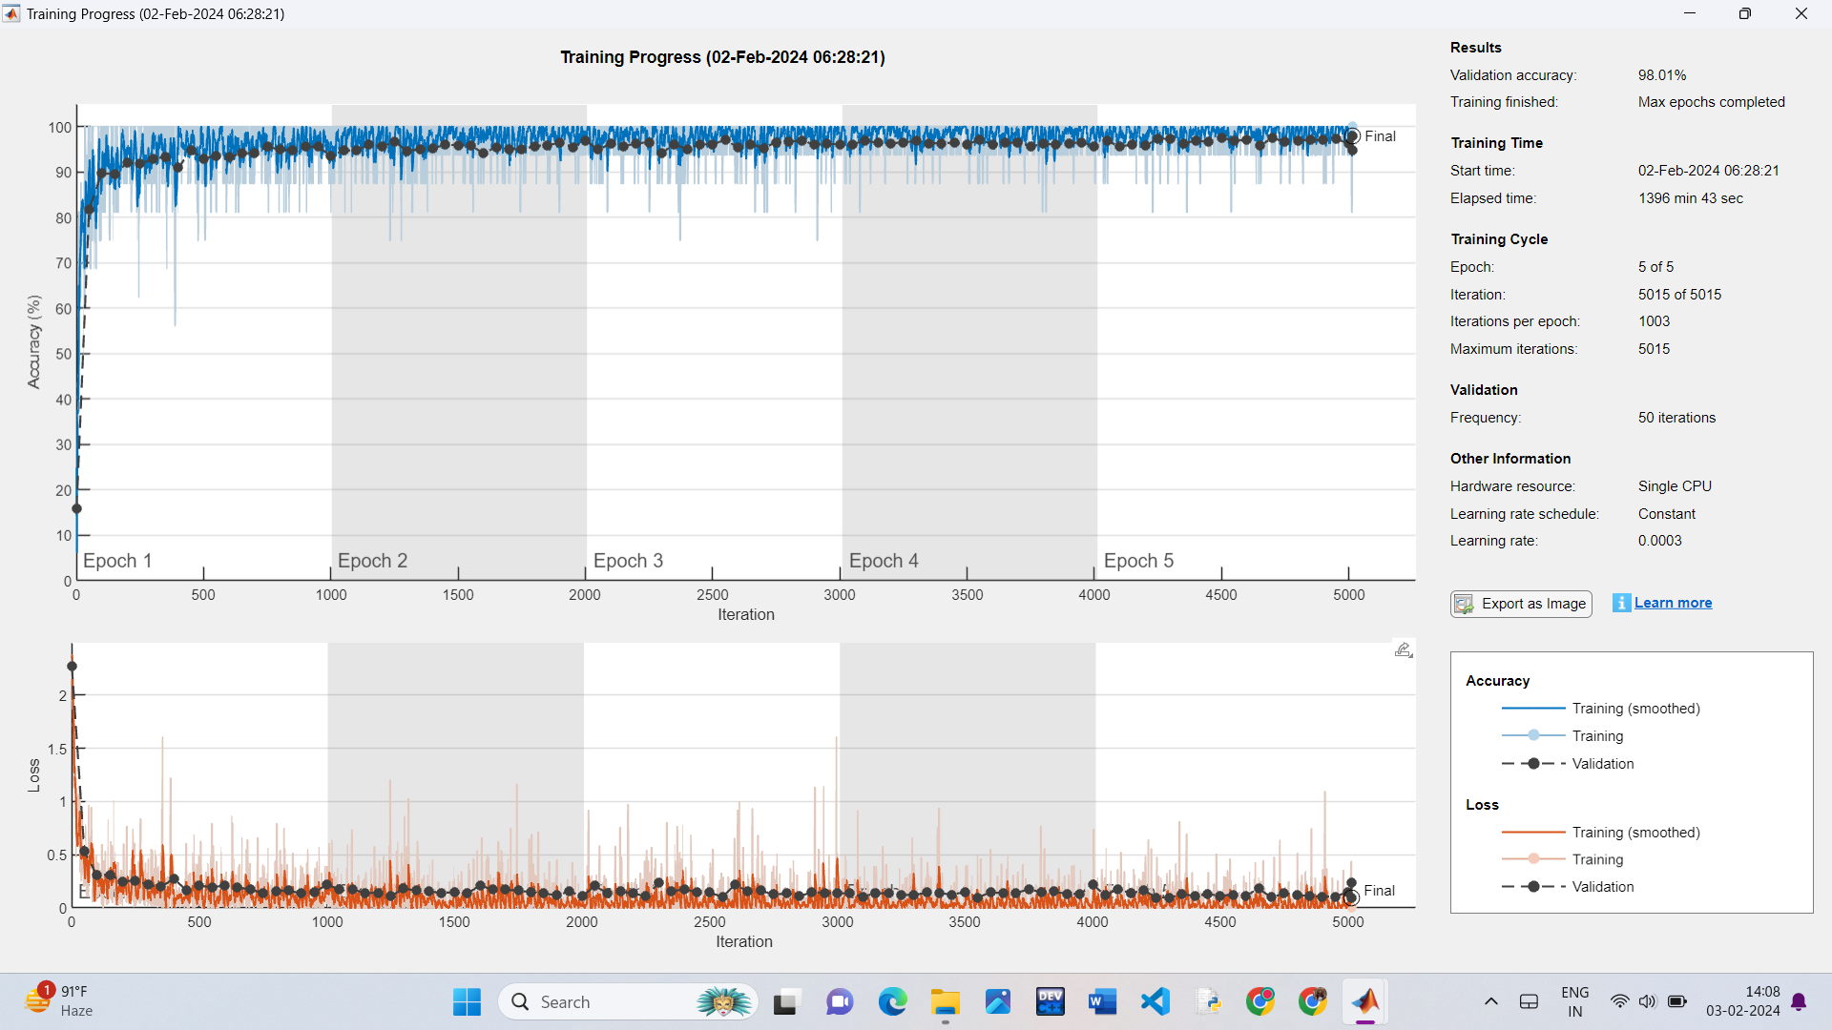

Fig 4.1. Feature Extraction from Tomato Plant Dataset

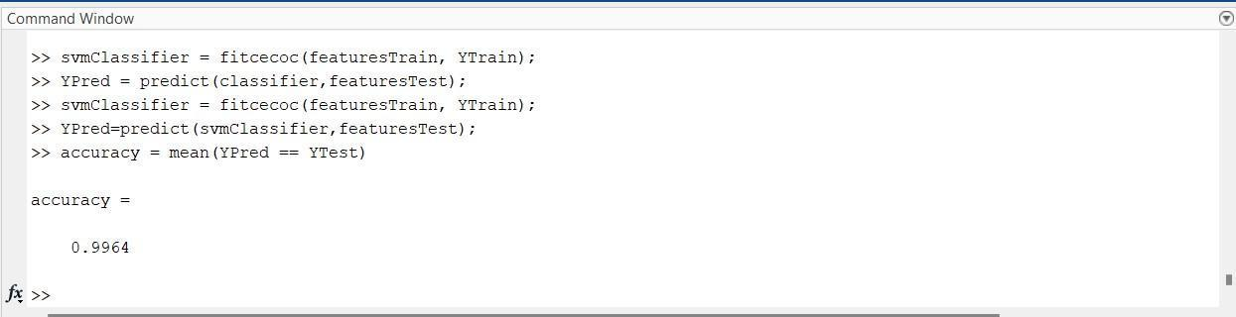

Fig 4.2. Classification using SVM

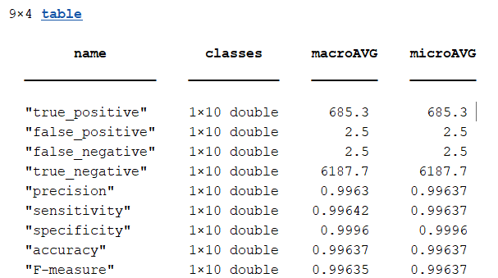

Fig 4.3 Deep Learning Metrics

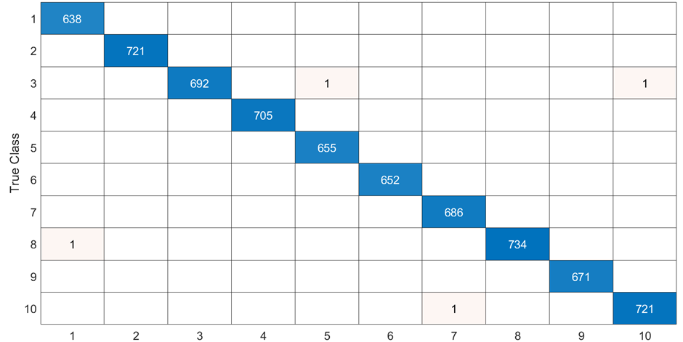

Fig 4.4 Confusion Matrix for Quadratic SVM

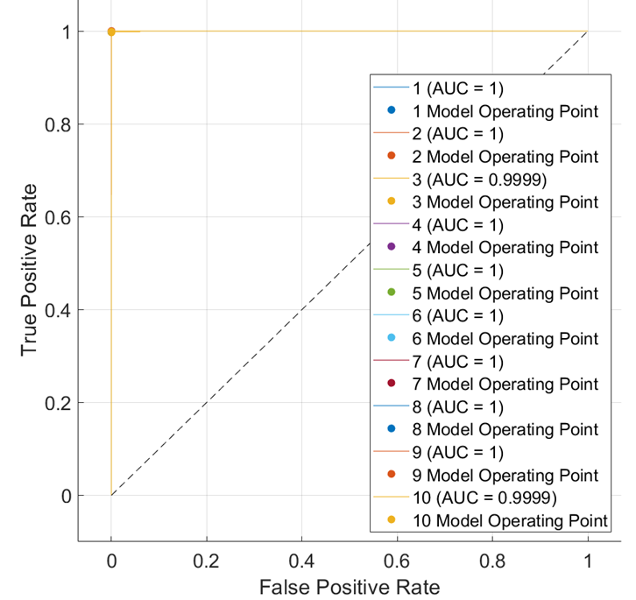

Fig 4.5 ROC for Quadratic SVM

|  |  |  |  |  |
| --- | --- | --- | --- | --- |
| S. No | Name | Original Image | Convolutional 2D | Sigmoid Layer |
| 1 | Bacterial spot |  |  |  |
| 2 | Early blight |  |  |  |
| 3 | Late blight |  |  |  |
| 4 | Leaf Mold |  |  |  |
| 5 | Septoria leaf spot |  |  |  |
| 6 | Spider mites Two spotted spider mite |  |  |  |
| 7 | Target Spot |  |  |  |
| 8 | Tomato Yellow Leaf Curl Virus |  |  |  |
| 9 | Tomato Mosaic Virus |  |  |  |
| 10 | healthy |  |  |  |

Fig 4.6 Meta-Visualization using Grad-CAM for leaves

**4.2. Grape Plant Disease Detection:**

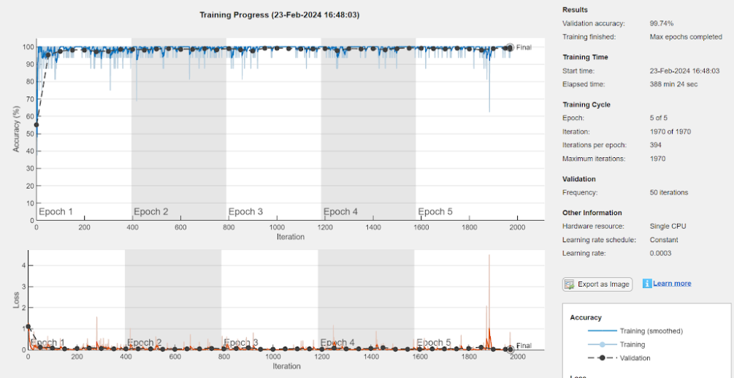

Fig 4.7 Feature Extraction from Grape Plant Dataset

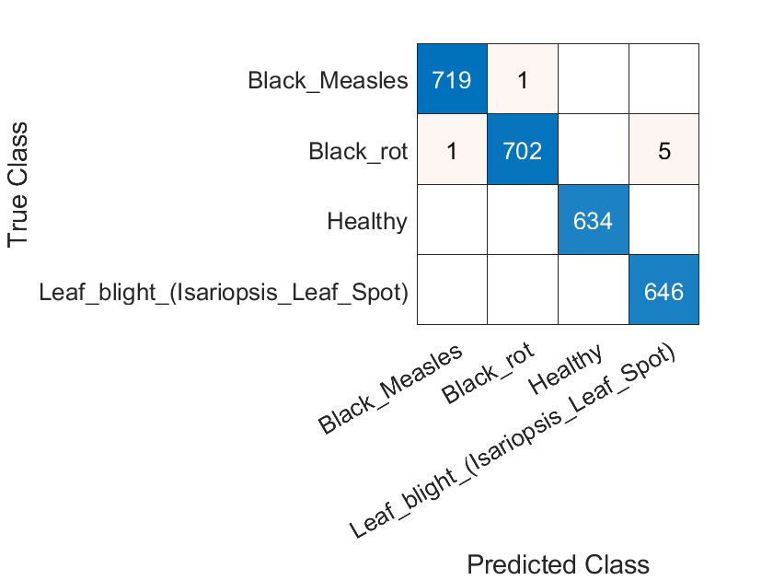

Fig 4.8 Confusion Matrix

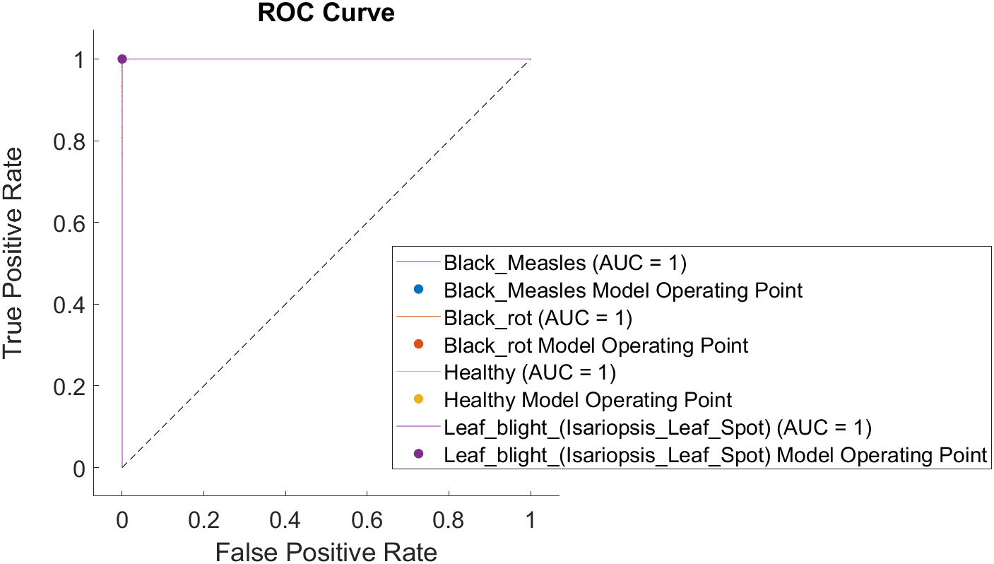

Fig 4.9 ROC Curve

|  |  |  |  |  |  |
| --- | --- | --- | --- | --- | --- |
| S.No | Names | Original Image | Sigmoid Layer  (Grad-CAM1) | Average-pooling Layer  (Grad-CAM2) | Convolutional_2D Layer  (Grad-CAM3) |
| 1 | Black_Measles |  |  |  |  |
| 2 | Black_rot |  |  |  |  |
| 3 | Healthy |  |  |  |  |
| 4 | Leaf_blight_(Isariopsis_Leaf_Spot) |  |  |  |  |

Fig 4.10 Meta-Visualization using Grad-CAM for leaves.

**4.3. Maize Plant Disease Detection:**

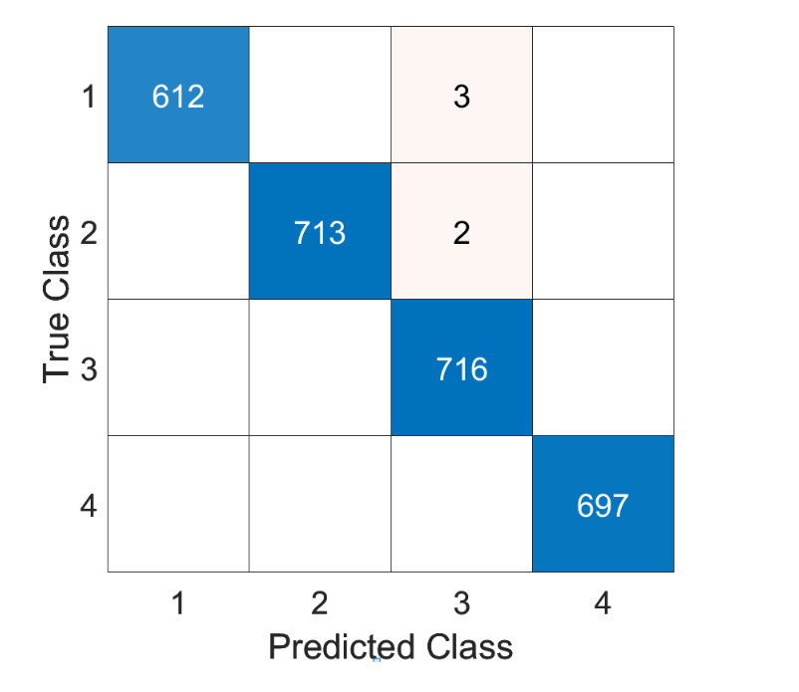

Fig 4.11. Confusion Matrix for Wide Neural Network.

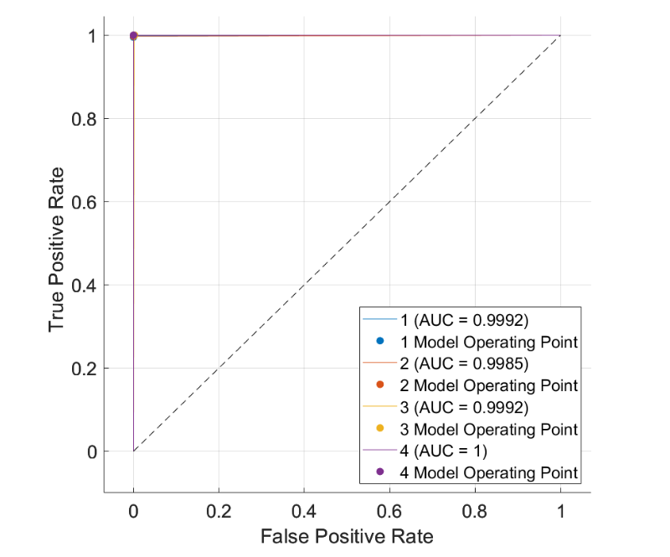

Fig 4.12. ROC Curve for Wide Neural Network.

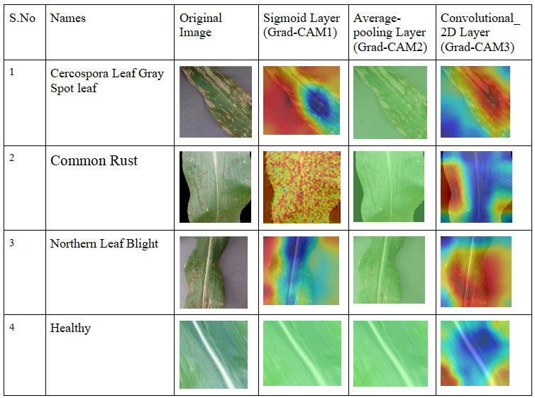

Fig 4.13 Meta-Visualization using Grad-CAM for Maize leaves

**CHAPTER 5**

**5.1. CONCLUSION AND FUTURE PLANS:**

The agricultural sector in India depends greatly on crops, which are crucial for the economy and food security of the nation. Unfortunately, diseases like blight can severely impact crops such as tomato, grapes, and corn, resulting in reduced yields, poor quality harvests, and financial losses. Therefore, the implementation of effective disease detection techniques is essential to sustain agricultural productivity.The approach we propose relies on deep convolutional neural networks and machine learning to effectively detect diseases in plant leaf images of tomato, corn, and grapes, as well as identify healthy plants. Our model achieves an impressive accuracy of 99.64% on the tomato dataset, an accuracy of 99.81% on the maize plant dataset and an accuracy of on the grapes plant dataset showcasing its strong performance. Furthermore, deploying these advanced models on edge devices like smartphones empowers farmers and stakeholders with efficient access to this technology. To enhance usability, future research could focus on integrating this technology with user-friendly interfaces, enabling farmers to capture real-time images of their crops for swift diagnosis and intervention. This direction holds significant promise for driving further advancements in the field of agriculture.

**CHAPTER 6**

**6.1. REFERENCES**

1.Islam, S. U., Zaib, S., Ferraioli, G., Pascazio, V., Schirinzi, G., & Husnain, G. (2024). Enhanced Deep Learning Architecture for Rapid and Accurate Tomato Plant Disease Diagnosis. *AgriEngineering*, *6*(1), 375-395.

2. Chen, Z., Wang, G., Lv, T., & Zhang, X. (2024). Using a Hybrid Convolutional Neural Network with a Transformer Model for Tomato Leaf Disease Detection. *Agronomy*, *14*(4), 673.

3. Ullah, Z., Alsubaie, N., Jamjoom, M., Alajmani, S. H., & Saleem, F. (2023). EffiMob-Net: A deep learning-based hybrid model for detection and identification of tomato diseases using leaf images. *Agriculture*, *13*(3), 737.

4. Roy, K., Chaudhuri, S. S., Frnda, J., Bandopadhyay, S., Ray, I. J., Banerjee, S., & Nedoma, J. (2023). Detection of tomato leaf diseases for agro-based industries using novel PCA DeepNet. *IEEE Access*, *11*, 14983-15001.

5. Anim-Ayeko, A. O., Schillaci, C., & Lipani, A. (2023). Automatic blight disease detection in potato (Solanum tuberosum L.) and tomato (Solanum lycopersicum, L. 1753) plants using deep learning. *Smart Agricultural Technology*, *4*, 100178.

6. Chong, H. M., Yap, X. Y., & Chia, K. S. (2023). Effects of different pretrained deep learning algorithms as feature extractor in tomato plant health classification. *Pattern Recognition and Image Analysis*, *33*(1), 39-46.

7. Kumar, Y., Singh, R., Moudgil, M. R., & Kamini. (2023). A systematic review of different categories of plant disease detection using deep learning-based approaches. *Archives of Computational Methods in Engineering*, *30*(8), 4757-4779.

8. Baser, P., Saini, J. R., & Kotecha, K. (2023). TomConv: An improved CNN model for diagnosis of diseases in tomato plant leaves. *Procedia Computer Science*, *218*, 1825-1833.

9.Tarek, H., Aly, H., Eisa, S., & Abul-Soud, M. (2022). Optimized deep learning algorithms for tomato leaf disease detection with hardware deployment. *Electronics*, *11*(1), 140.

10.Kaur, P., Harnal, S., Gautam, V., Singh, M. P., & Singh, S. P. (2022). An approach for characterization of infected area in tomato leaf disease based on deep learning and object detection technique. *Engineering Applications of Artificial Intelligence*, *115*, 105210.

11.Islam, M. S., Sultana, S., Farid, F. A., Islam, M. N., Rashid, M., Bari, B. S., ... & Husen, M. N. (2022). Multimodal hybrid deep learning approach to detect tomato leaf disease using attention based dilated convolution feature extractor with logistic regression classification. *Sensors*, *22*(16), 6079.

12.Sakkarvarthi, G., Sathianesan, G. W., Murugan, V. S., Reddy, A. J., Jayagopal, P., & Elsisi, M. (2022). Detection and classification of tomato crop disease using convolutional neural network. *Electronics*, *11*(21), 3618.

13.Anandhakrishnan, T., & Jaisakthi, S. M. (2022). Deep Convolutional Neural Networks for image based tomato leaf disease detection. *Sustainable Chemistry and Pharmacy*, *30*, 100793.

14. Özbılge, E., Ulukök, M. K., Toygar, Ö., & Ozbılge, E. (2022). Tomato disease recognition using a compact convolutional neural network. *IEEE Access*, *10*, 77213-77224.

15.Altalak, M., Uddin, M. A., Alajmi, A., & Rizg, A. (2022). A hybrid approach for the detection and classification of tomato leaf diseases. *Applied Sciences*, *12*(16), 8182.

16.Tan, L., Lu, J., & Jiang, H. (2021). Tomato leaf diseases classification based on leaf images: a comparison between classical machine learning and deep learning methods. *AgriEngineering*, *3*(3), 542-558.

17. Abbas, A., Jain, S., Gour, M., & Vankudothu, S. (2021). Tomato plant disease detection using transfer learning with C-GAN synthetic images. *Computers and Electronics in Agriculture*, *187*, 106279.

18.Zhao, S., Peng, Y., Liu, J., & Wu, S. (2021). Tomato leaf disease diagnosis based on improved convolution neural network by attention module. *Agriculture*, *11*(7), 651.

19. Prabhakar, M., Purushothaman, R., & Awasthi, D. P. (2020). Deep learning based assessment of disease severity for early blight in tomato crop. *Multimedia Tools and Applications*, *79*, 28773-28784.

20.Agarwal, M., Gupta, S. K., & Biswas, K. K. (2020). Development of Efficient CNN model for Tomato crop disease identification. *Sustainable Computing: Informatics and Systems*, *28*, 100407.

21.Rai, C. K., & Pahuja, R. (2024). Northern maize leaf blight disease detection and segmentation using deep convolution neural networks. *Multimedia Tools and Applications*, *83*(7), 19415-19432.

22.Dash, A., & Sethy, P. K. (2024). Statistical analysis and comparison of deep convolutional neural network models for the identification and classification of maize leaf diseases. *Multimedia Tools and Applications*, 1-14.

23.Jasrotia, S., Yadav, J., Rajpal, N., Arora, M., & Chaudhary, J. (2023). Convolutional neural network based maize plant disease identification. *Procedia Computer Science*, *218*, 1712-1721.

24.Li, E., Wang, L., Xie, Q., Gao, R., Su, Z., & Li, Y. (2023). A novel deep learning method for maize disease identification based on small sample-size and complex background datasets. *Ecological Informatics*, *75*, 102011.

25.Masood, M., Nawaz, M., Nazir, T., Javed, A., Alkanhel, R., Elmannai, H., ... & Bourouis, S. (2023). MaizeNet: A deep learning approach for effective recognition of maize plant leaf diseases. *IEEE Access*.

26.Singh, R. K., Tiwari, A., & Gupta, R. K. (2022). Deep transfer modeling for classification of maize plant leaf disease. *Multimedia Tools and Applications*, *81*(5), 6051-6067.

27. Amin, H., Darwish, A., Hassanien, A. E., & Soliman, M. (2022). End-to-end deep learning model for corn leaf disease classification. *IEEE Access*, *10*, 31103-31115.

28.Subramanian, M., Shanmugavadivel, K., & Nandhini, P. S. (2022). On fine-tuning deep learning models using transfer learning and hyper-parameters optimization for disease identification in maize leaves. *Neural Computing and Applications*, *34*(16), 13951-13968.

29. Yu, H., Liu, J., Chen, C., Heidari, A. A., Zhang, Q., Chen, H., ... & Turabieh, H. (2021). Corn leaf diseases diagnosis based on K-means clustering and deep learning. *IEEE Access*, *9*, 143824-143835.

30.Mishra, S., Sachan, R., & Rajpal, D. (2020). Deep convolutional neural network based detection system for real-time corn plant disease recognition. *Procedia Computer Science*, *167*, 2003-2010.

31. Sood, S., & Singh, H. (2024). A comparative study of grape crop disease classification using various transfer learning techniques. *Multimedia Tools and Applications*, *83*(2), 4359-4382.

32. Kunduracioglu, I., & Pacal, I. (2024). Advancements in deep learning for accurate classification of grape leaves and diagnosis of grape diseases. *Journal of Plant Diseases and Protection*, 1-20.

33. Billa, S. R., Malik, V., Bharath, E., & Sharma, S. (2024). Grapevine fruits disease detection using different deep learning models. *Multimedia Tools and Applications*, 1-26.

**CHAPTER 7**

**7.1. APPENDIX:**

**BASE PAPER**

Sunil, C. K., Jaidhar, C. D., & Patil, N. (2023). Tomato plant disease classification using multilevel feature fusion with adaptive channel spatial and pixel attention mechanism. *Expert Systems with Applications*, *228*, 120381.

**doi**:10.1016/j.eswa.2023.120381

**keywords**: {Deep learning; Feature extraction; Training; Neural networks;Machine Learning ; Classification},

**URL**:

<https://www.sciencedirect.com/science/article/abs/pii/S0957417423008837>